Table of Contents
1. Introduction ________________________________________________PG. 1
2. How to open a document in Kurzweil____________________________PG. 3
3. Using Content on Web________________________________________PG. 5
4. How to use Kurzweil for a test on Blackboard______________________PG. 7
5. Using Study Skill Tools_______________________________________PG. 9
6. Audio Files_________________________________________________PG. 12
7. How to Extract Annotations____________________________________PG. 15
8. Downloading Electronic Content________________________________PG. 18
9. Writing and Editing___________________________________________PG. 19
10. Using Outline______________________________________________PG. 23
11. Creating a Draft____________________________________________PG. 25
12. How to Import Word Lists into Kurzweil for Word Prediction_______PG. 28

Kurzweil 3000 V. 11 Training Manual

Kurzweil 3000 is a Reading, Writing and Learning Software that our department provides at all open access labs across campus. Some students receiving alternate media as an accommodation are approved for a Kurzweil License To Go which they can install on their home computer/laptop. Currently this license to go option is only available for pc’s (not mac). Here are a few of the benefits of using Kurzweil 3000:
Increased Reading Fluency – Provides the tools you need to improve your reading speed and comprehension, and features that make it possible for independent learning and studying
Study Skills - With the aid of visual and auditory feedback, the software helps you keep up with assigned reading, learn critical study skills and successfully complete writing projects and tests
Decoding Support - It then reads the words aloud to you in a clear, humanlike, synthetic speech, while a patented dual highlighting feature adds visual reinforcement
Writing and Self-Editing Tools – As you type, the software speaks each letter or word, so you can quickly recognize and correct spelling mistakes. The Check Spelling as You Type feature underlines misspelled words in red. There is also an audible spell checker and customizable word prediction further assistance.

Now let’s get started using Kurzweil!

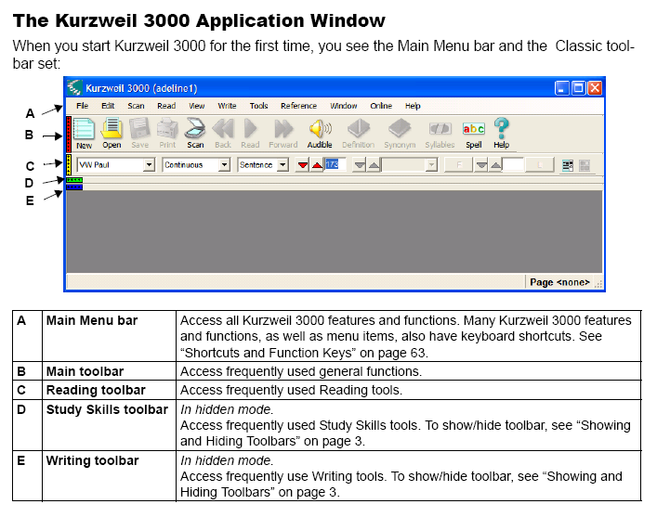

The Default Toolbars by color
Red bar is main tool bar
Yellow is the reading menu
Green is study skills
Blue is writing toolbar
How to open a document in Kurzweil
Copy document from cdrom to local computer (because it is copyrighted and will be a “read only” doc otherwise)
To open a document: Click the Open button in the Main toolbar. In the Open dialog, navigate to and open the desired file.

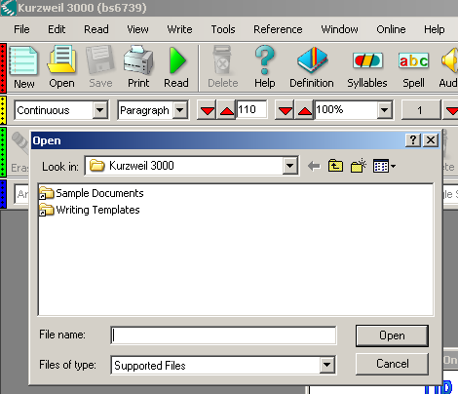

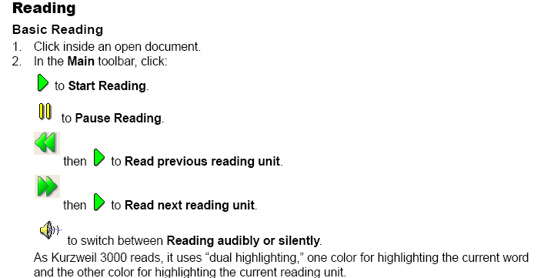
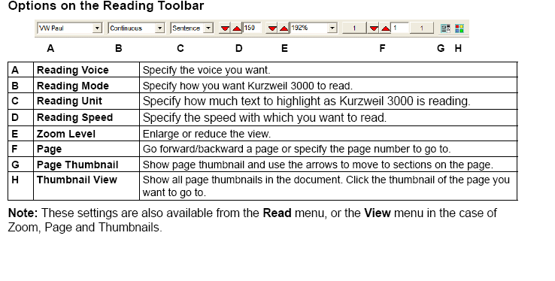
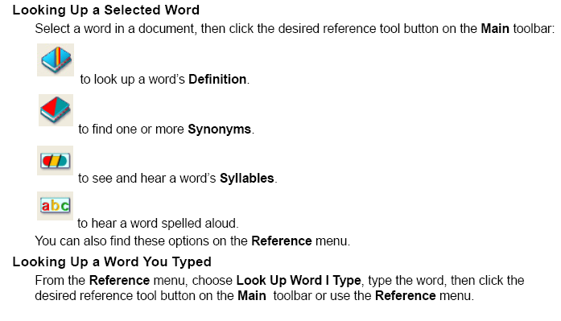
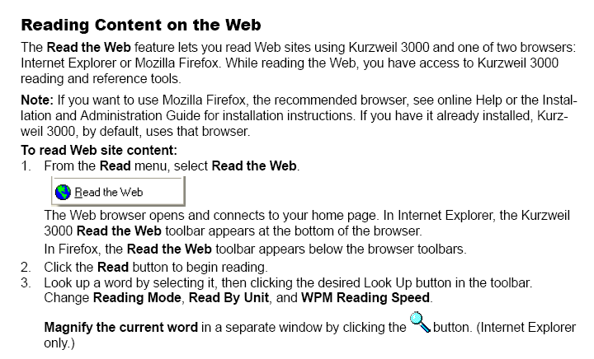

IF YOU WANT TO USE FIREFOX AND IT DOESN’T WORK FOLLOW THE STEPS BELOW:
Steps
1. In Firefox, verify that an older version of the K3000 Read the Web add-on is not already installed. Launch Firefox. In Firefox, click Tools -> Add-ons. In your Extensions list, locate any add-on labeled Read the Web or KESIReader, select it, and click the Remove button. Restart Firefox after removing the add-on.
2. You may see kesireader.xpi file(this is the new Read the Web add-on) in this folder (\Manuals\Software\AT\How-to-use\Kurzweil).
3. Drag and drop the .xpi file into an open Firefox window. You will be prompted to install the add-on. Follow the prompts to install. And then enable it so you may see the kurzweil toolbar on top.
4. Close Firefox
5. Open Firefox again
6. Open Kurzweil and click on read from web
Because we are using a new add-on with an outdated version of K3000, we will be limited in how we can use Read the Web. If we attempt to launch Read the Web through the K3000 menu, we will get stuck in an installation prompt loop. We will not be able to launch Firefox and Read the Web.
The solution is to simply launch Firefox independent of K3000 and click the Read button in the Firefox Reading toolbar. In other words, don't try to Read the Web from K3000 -- only use the Read button in Firefox.

How to use Kurzweil for a test on Blackboard
Step 1. Open Firefox browser, and then go to the blackboard site.
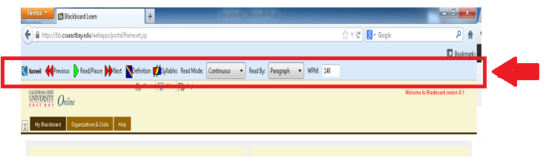
Step 2. Check whether you are getting the Kurzweil menu bar on the Firefox browser. If you cannot see the menu bar then follow the steps written on page 6.
Step 3.
Then just click on the 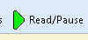 Read Pause button on the menu bar
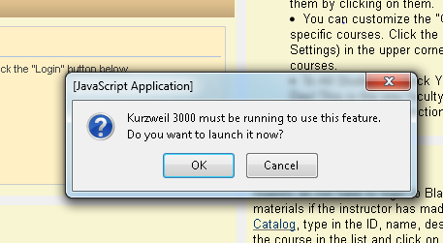
Click ok and it will open of Kurzweil.
Step 4.
Enter your credential to login to your Kurzweil account. Use your net ID as username and lastname as password. Press enter to login to Kurzweil.
Step 5.
Once kurzweil is opened , again go to your firefox browser where you opened your blackboard site.
Step 6.
Click on the button again and the Kurzweil starts reading the web page.

Some tips
- To make Kurzweil read from any particular point in the webpage. Just click on that part of the page and click on the read/pause button.

- You need to press button on every single. It will not start automatically read, so once this is pressed it will start reading.

- If it freezes or crashes just click on the button.

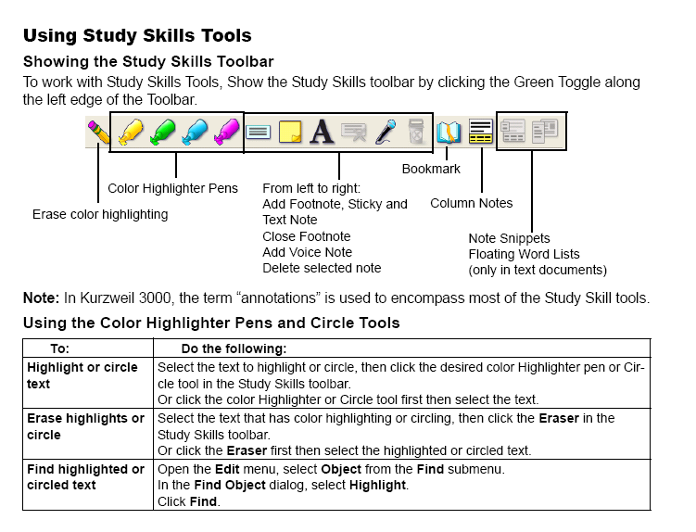
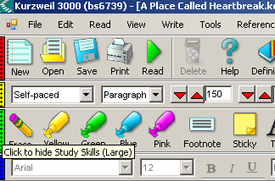
Green toggle

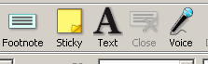
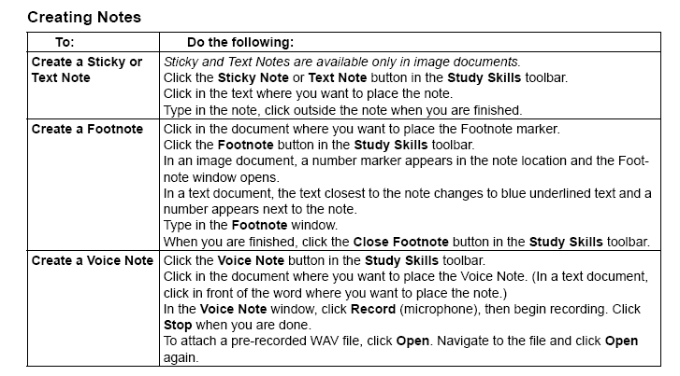

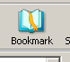
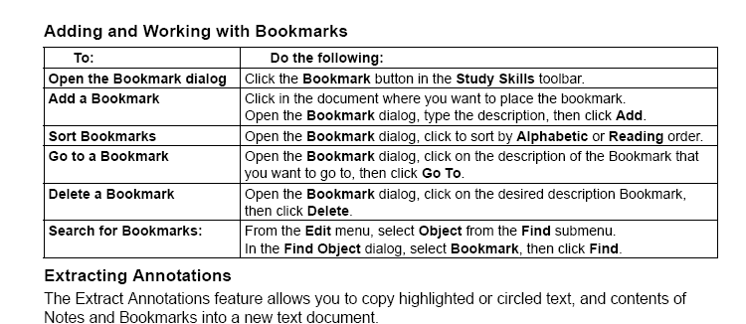

AUDIO FILES
If you’re in a hurry and need to listen to a few chapters on your mp3 player or cd player, you can easily create an audio file.
1) Select File, audio files, create audio file
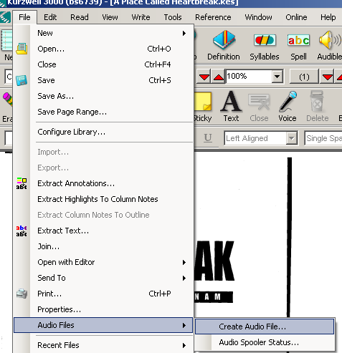

Select entire document or enter pages you would like to convert to audio, accept defaults, click ok
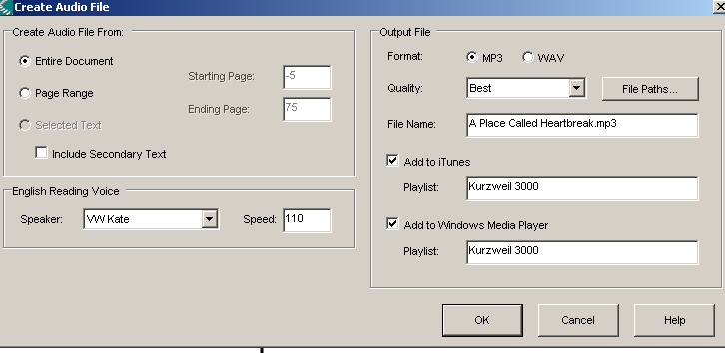
Your audio file will be saved to the Kurzweil output folder on your desktop
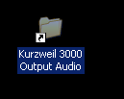Simply drag file from here to your media library (eg itunes, windows media player) library or cdrom to burn.

Looking Up Information in Online Encyclopedias and Reference Sites
- Select a word or phrase.
- From the Online menu, select Online Reference Lookup.
- In the Online Reference Lookup dialog, select a Search Site from the list, then click Search:
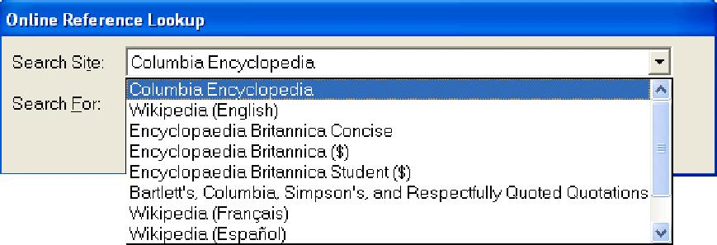

Extracting Annotations – Extracting annotations will allow you to highlight the important details and then extract them to a separate document for studying or to prepare to write your term paper.

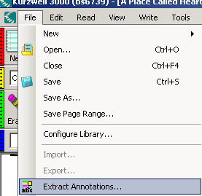

The Extract Annotations feature allows you to copy highlighted or circled text, and contents of
Notes and Bookmarks into a new text document.

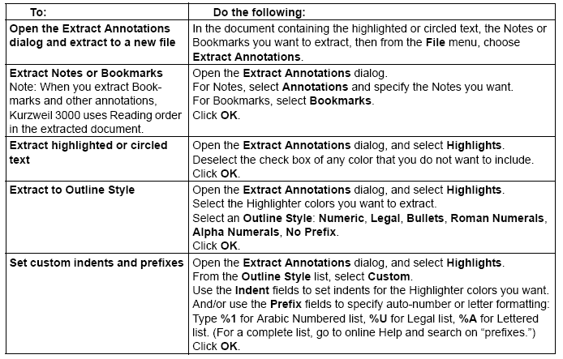
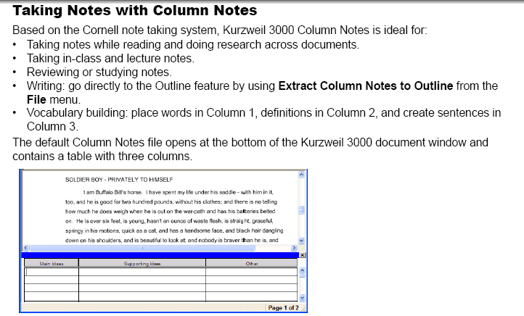

Extracting Highlights to Column Notes
- In a document, use the Color Highlighter tools from the Study Skills toolbar or from the Tools menu to highlight the different types and levels of information you want to collect. Click the Column Notes button or select Column Notes from the Tools menu.
- In the Open Column Notes dialog, select either to create a Blank Column Notes file or to open an Existing Column Notes file.
- From the File menu, select Extract Highlights to Column Notes or click its button.
- Specify the column number to which you want the text of a particular color highlight to fill: Column 1, 2 or 3. Other numbers are not valid.
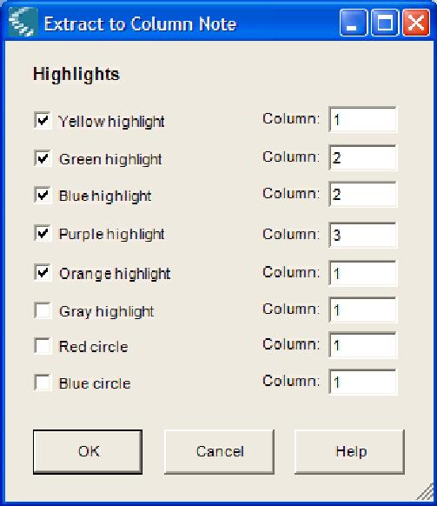
- Click OK. Kurzweil 3000 fills the Column Notes cells according to reading order and to the column numbers you specified.
- Save the Column Notes file. If you do not want the currently highlighted text to be extracted the next time you use Extract Highlights to Column Notes, Erase the highlights and Save the document.

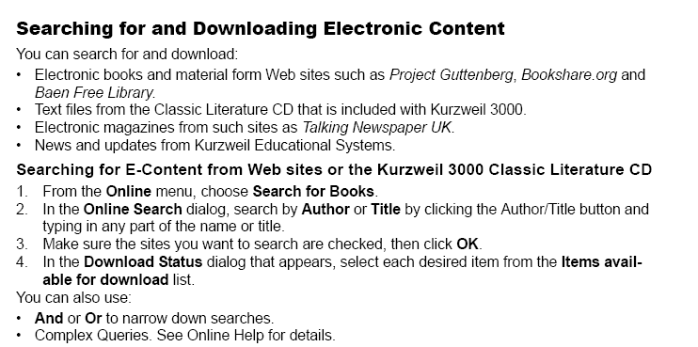
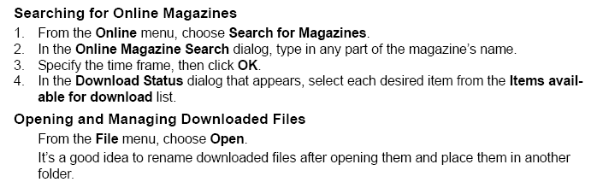

Writing and Editing
Showing the Writing Toolbar
When working with a “typed” text document, Show the Writing toolbar (blue) for easy access to frequently used text editing and formatting tools. Now as you type your document you can hear what you are typing so you can hear where you may be making a mistake with grammar or spelling.
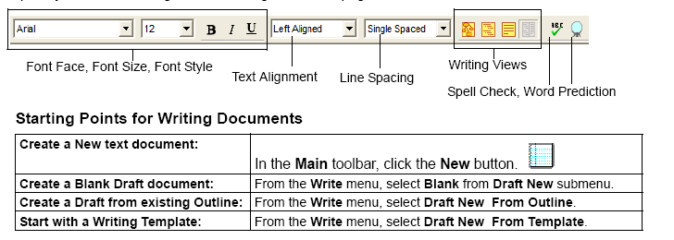
Adding a Picture
To insert a picture into a text document:
- In a text document, click where you want to insert the picture.
- From the Edit menu, choose Insert Picture.
- In the Open dialog, navigate to and select the picture file name you want, then click Open.
- Save the document in RTF format.
To copy and paste a picture into a text document:
- Display the picture that you want to copy and paste. The picture may be located in your file system, in an existing Kurzweil 3000 document or in a document from another application.
- Select the picture.
- From the Edit menu, choose Copy.
- Click in the location in the Kurzweil 3000 document where you want to paste the image.
- From the Edit menu, choose Paste.
- Save the document in RTF format.
Using Brainstorm
The writing process begins with brainstorming ideas and organizing your thoughts. Brainstorm,
part of Kurzweil 3000 integrated Writing Path, is a graphic organizer that allows you quickly collect
and organize your thoughts as you begin the writing process. (For more on the Writing Path, use
online Help Search.)
While in Brainstorm, you have access to familiar reading and editing functions, a tools palette, and
a comprehensive set of shortcut keys.
The graphic-based Brainstorm diagram that you create shares information with the text-based
Outline, allowing you to switch back and forth between the two views, while preserving your
thoughts, details, notes and organization.

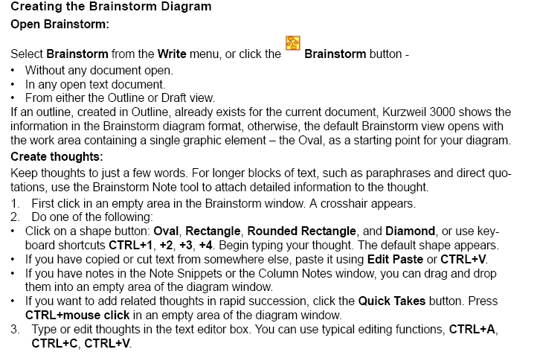

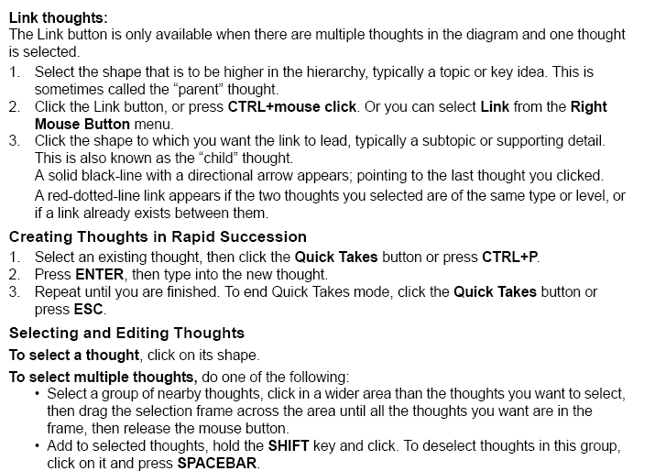
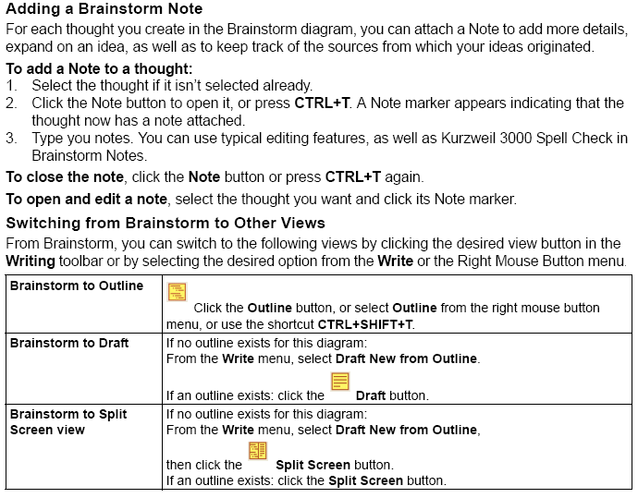
Using Outline
The outline is an alternative way to begin the writing process. Kurzweil 3000 Outline lets you jot down your ideas and organize your thoughts into a writing plan.
While working in Outline, you have access to familiar reading and editing functions, a tools palette, and a comprehensive set of shortcut keys. The text-based outline that you create shares information with the graphic-based Brainstorm diagram, allowing you to switch back and forth between the two views, while preserving your thoughts, details, notes and organization.
Creating an Outline
There are a number of ways to start an outline:
- From scratch using the default Outline.
- From Column Notes by using the Extract Column Notes to Outline feature.
- From an existing Brainstorm diagram by clicking the Outline button in Brainstorm.

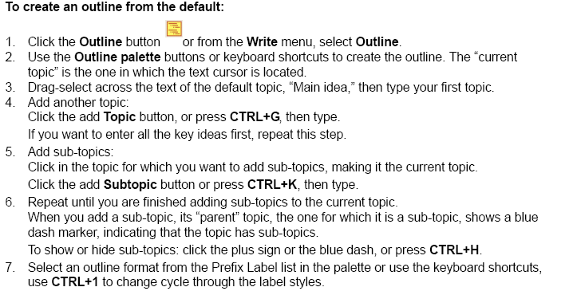
Selecting and Editing Outline Text and Topics
There are two types of text selection in Outline view:
- Regular text selection within a topic or note. Text in the Outline view cannot be selected across topics or across topics and notes. Regular text selection applies only to the selected text and does not select any sub-topics that a topic may have.
- Complete selection selects all the text in a topic as well as its associated sub-topics and notes. A complete selection of a Note selects all the note text.
To select and edit regular text:
Double-click to select a word. Drag-select letter, word or block of text. You can:
- Edit text using familiar editing functions such as, Cut/Copy/Paste, however, dragging and dropping text is not available in Outline.
- Deselect text by clicking elsewhere, however, be aware that if you click to the left of a line of text or in the area before any marker, you are performing a complete selection of the topic.
To select a whole topic or note:
Move the pointer to the area before the topic text or any marker, if it exists, then click, or press CTRL+SPACE. This applies to any level of topic in the Outline feature. After you click, the topic is highlighted. You can now Cut/Copy/Paste, delete or drag and drop to move it. Because it is a complete selection of the entire topic, the operation affects all of the topic’s sub-topics and notes.
To delete text in a topic without removing its number:
Select the text or select the topic, then press the DELETE key.
To delete a topic and its associated sub-topics and notes:
- Select the topic. The topic text should highlight indicating that it and all of its associated subtopics and notes are selected.
- Click the Delete button in the palette or press DELETE.

Creating and Working with Drafts
In the writing process, the stage after brainstorming and/or outlining is the actual “writing” stage, when you create drafts for your own review, for peer-editing, or for teacher approval. In the Kurzweil 3000 Writing Path, this is the Draft stage.
You can create a Blank or New draft document, create one from an existing Outline or Brainstorm diagram, or create one from a set of Writing Templates. In the Kurzweil 3000 Draft document you can:
- Open a Split Screen view where the associated outline shows along-side the Draft contents, allowing you to write while referencing the outline.
- Open a Review checklist, at any time, to help you methodically proofread and review your drafts.
- Switch to other Writing views: Brainstorm and Outline.
- Use familiar Kurzweil 3000 writing and editing functions including: Word Lookup, Word Prediction, Spell Check, Word Lists.

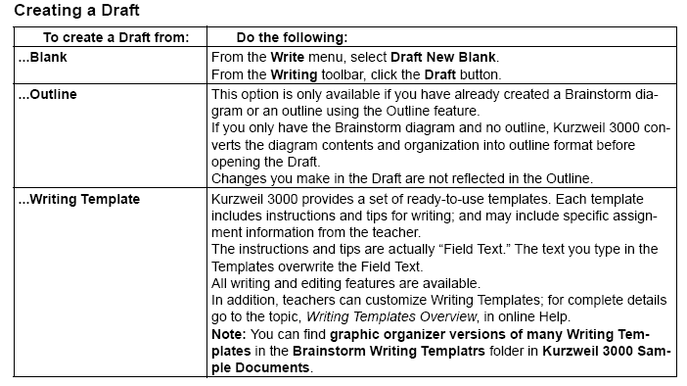
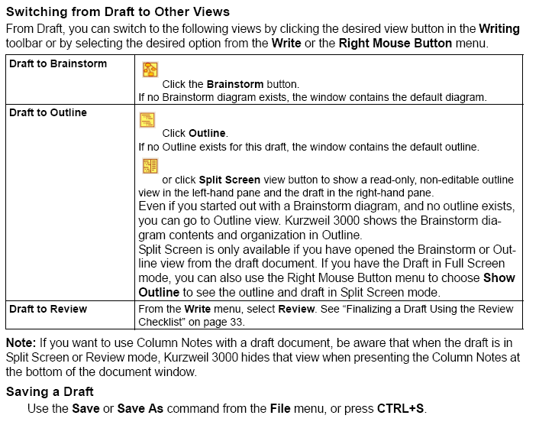

Finalizing a Draft Using the Review Checklist
The actual writing process is a cycle: write, review, rewrite. As part of the Kurzweil 3000 Writing
Path, the Review feature is on the Write menu; it opens in the left-hand pane with your draft in the right-hand pane.
The Review checklist is available any time (except when the Brainstorm or Outline Views is open) and for any Kurzweil 3000 text document.
The Review checklist comes with a default set of items that you can modify or add to in the Tools
Options dialog. You can have a total of 10 items in the checklist.
To review a text document:
In the draft document, go to the Write menu and select Review.
Perform each task in the checklist, for instance, run the spell checker, or open the Word List you should be using with your writing assignment.
When you are finished with each task, click the appropriate checkbox in the Review checklist. If the Speak Buttons option is selected in General Options, Kurzweil 3000 reads the item’s description when you roll over its name, and speaks the item name when you check its box. It’s possible to complete the checklist items over multiple sessions. Kurzweil 3000 saves the current list status for subsequent sessions.
To end a review session, close the Review pane.

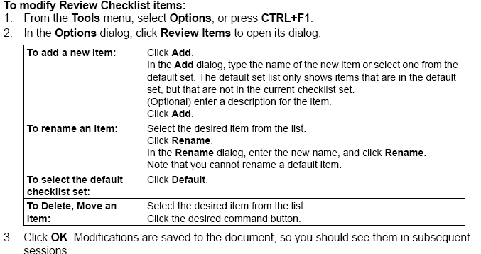

How to Import word lists into Kurzweil for Word prediction
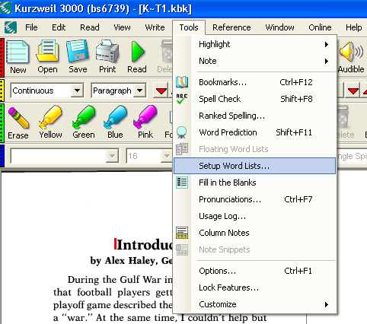

Tools/Setup Word Lists
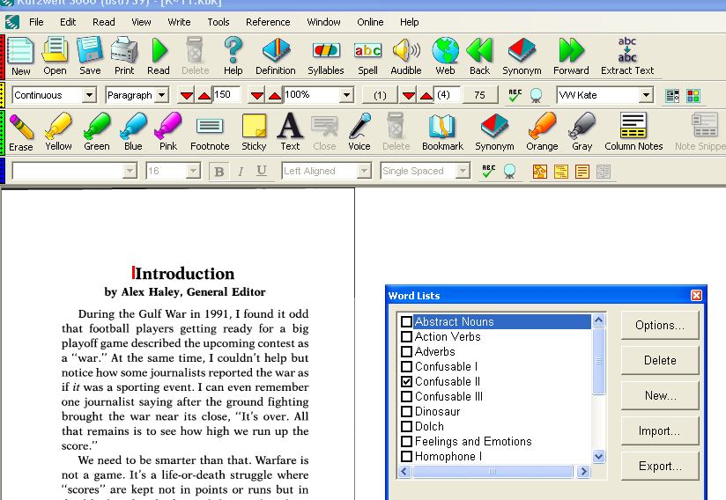
Select New
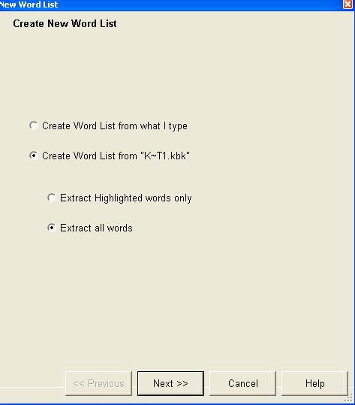
Create word list from “Textbook name”
Extract all words “Next”
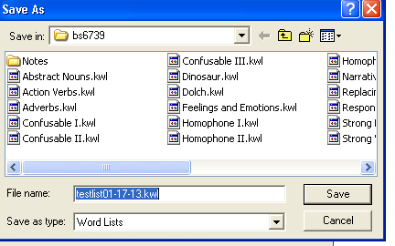Save File
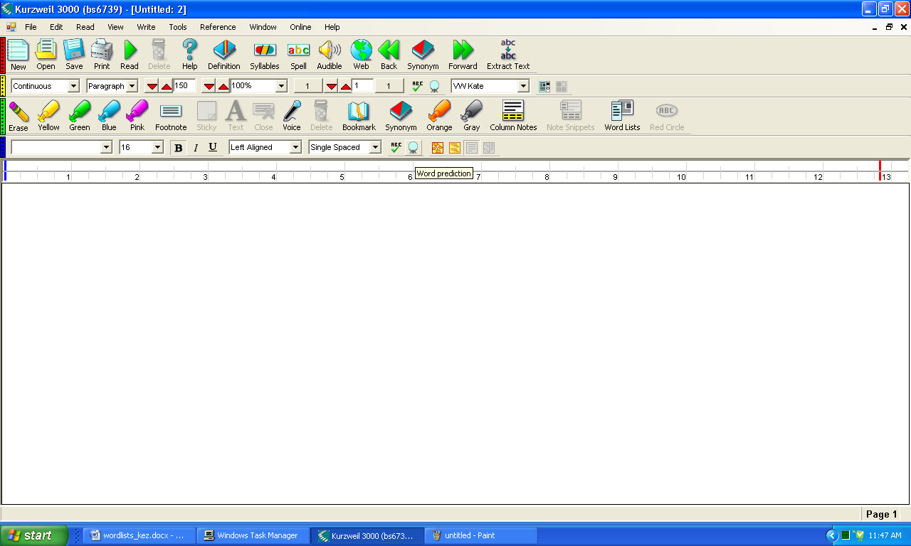
Now click file new and begin to type your paper, make sure to turn on word prediction first, you will notice that the vocabulary from your book starts to populate the word prediction list, for my example I am looking for the word squadron to pop up which wasn’t their before I added this word list.
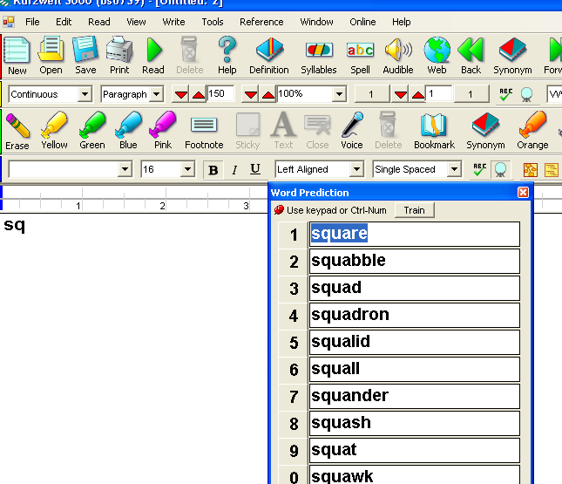
There it is, as soon as I started typing sq, my word came up.

Well these are the basics and a little more! If you have any questions or need any further assistance, please don’t hesitate to call the ATSO office @ 510 885-4366, or you can email us at atstudent@csueastbay.edu.

