Dragon Naturally Speaking 10
Training Manual




Assistive technology Services Office
LI 1121 (Library Basement)

Dragon Manual: Getting Started
1: Opening the Dragon bar. When you click on the dragon icon the below window appears.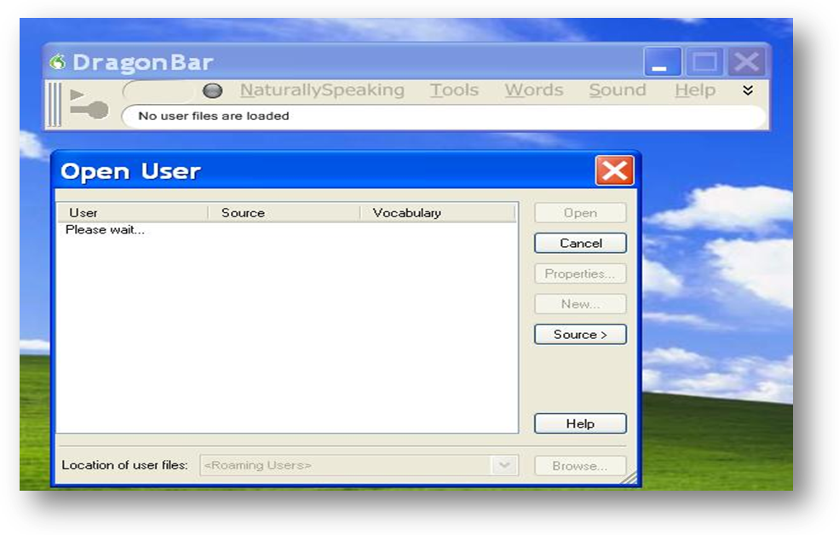
2: Selecting your user profile. Click on the New button to create a new user profile. This profile will hold all your information in terms of your speech data and your name associated with the data. 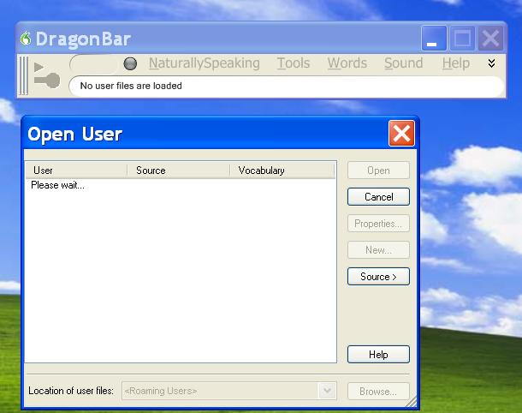

3: The below window appears next and you will need to fill in all the information to create a new user profile. Once done then click on the next button to go to the next step.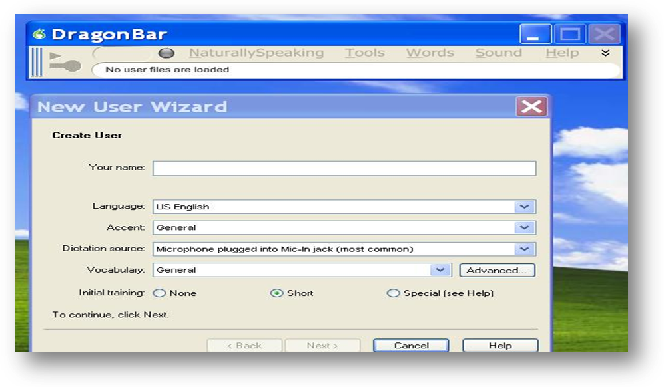
- The second option is of the language kindly select the US English as it is the most general way of speech.
- The third option is of the accent kindly select the the coressponding option which best suits your basic accent.
- The fourth menu is the Dictation source menu that shows the different settings for a microphone set-up. Kindly choose the first option that is if your microphone is already plugged into the computer .

The picture below shows the back of a computer where the microphone and the heaqdphones jack are to be connected. The black arrow is where the headphones are connected and red arrow is where the microphone jack goes. (the picture is of a specific computer, not to be taken as a general option on all systems.)
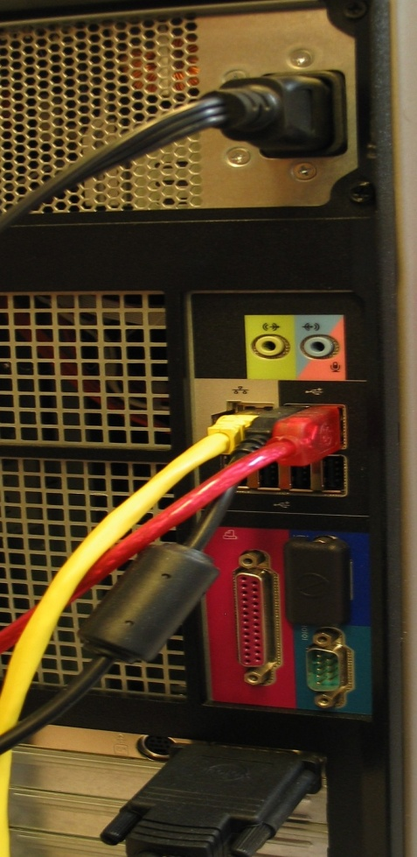

4: The next window is where the tutorial for the voice dictation will start. It has 3 steps
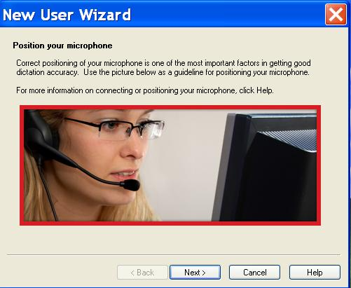

5: Volume check:- Dragon determined if your voice through is optimal.

.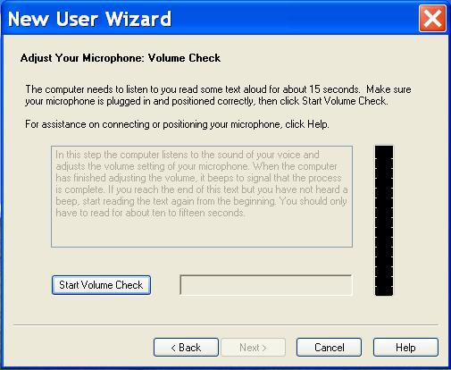

6: Sound Quality: Dragon determines if the quality of the microphone is optimal
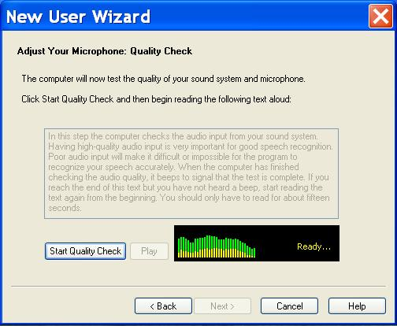

7: The dictation. A series of sentences and paragraphs provided by DNS programming will appear for you to read. Read the provided text .
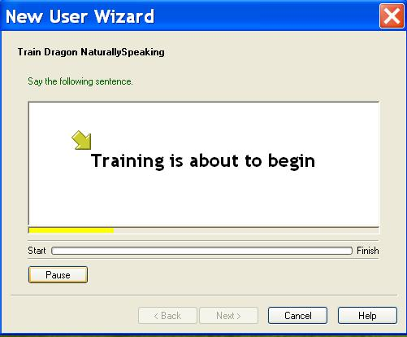
The progress of your training will be measured here.Continue the training until finished and click finish and okay when allowed
Select ‘Talking to your Computer (Easier Reading Instructional)’ to complete this part of the training
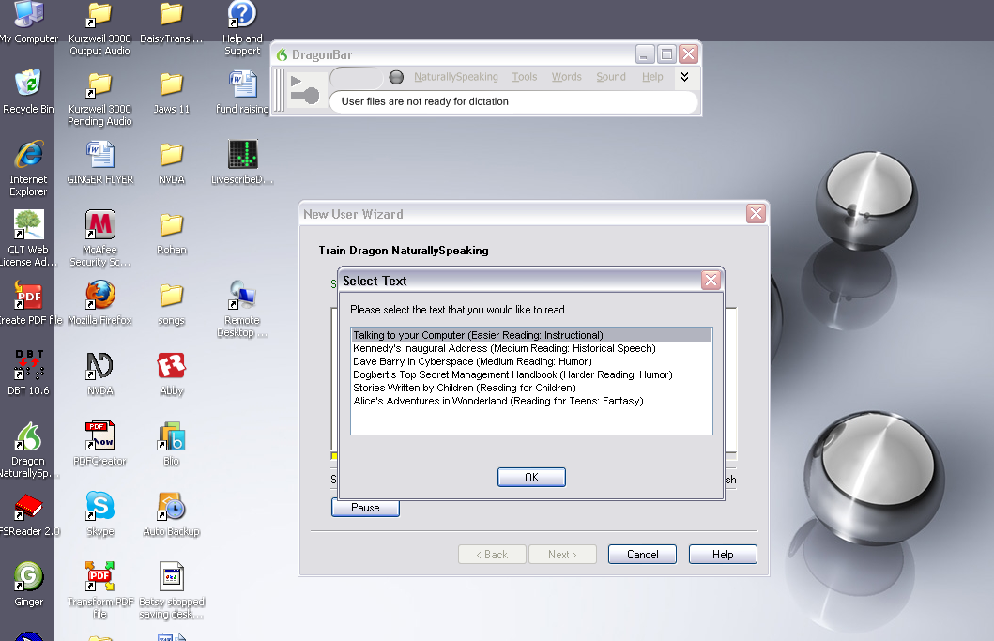

8: DNS will automatically scan documents sampled from your computer to adapt to your writing style after you click ‘start’.
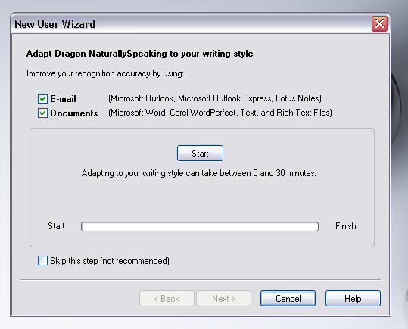
Click ‘next’ when process is finished

9: If this screen pops up select ‘Don’t run Data Collecting for this user’. 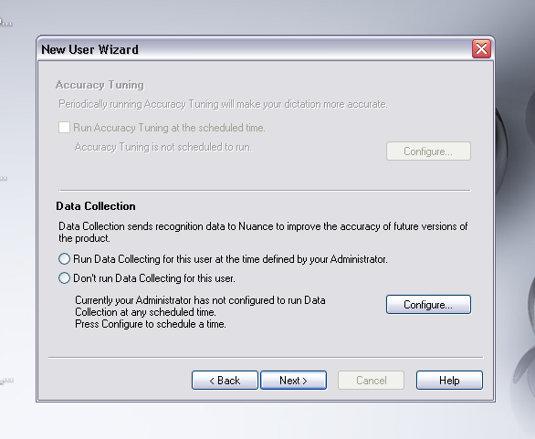Once you have made the selection if an additional screen will pop up you should decline this offer.

10: Select ‘Begin Dictating’. This will help you get hands on experience with DNS.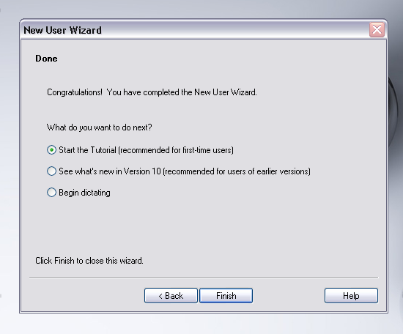

11: Wizard screen will disappear and you should be left with the DragonBar to use. Click on ‘Tools’and then ‘Dictation Box’.
From here you can use DNS to record your words and follow voice commands.
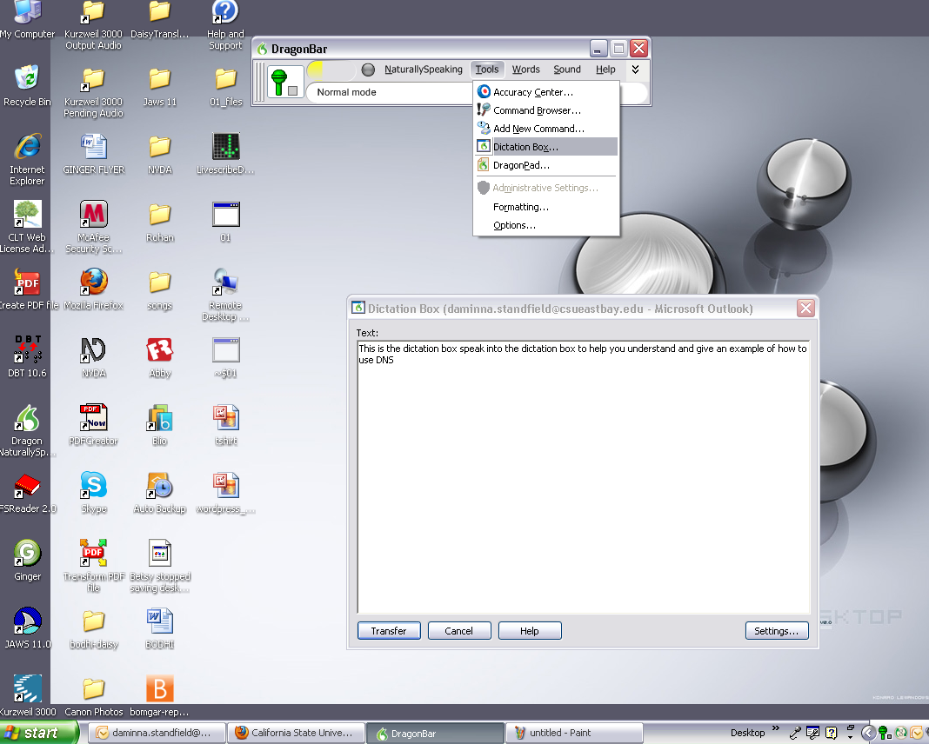
Begin speaking into the microphone and DNS Dictation Box should record what you are saying (as in the above example).
Note: by selecting ‘transfer’ you can send dictations in an email form.

Using Dragon Pad
12: Once you have finished the dictation you will then be able to use dragon with your voice commands and to do so click on the Tools button on the Dragon Bar and then on the dictation pad as shown. Or you can use voice command (keep microphone on) and say ‘tools’. Then say ‘dragon pad’.
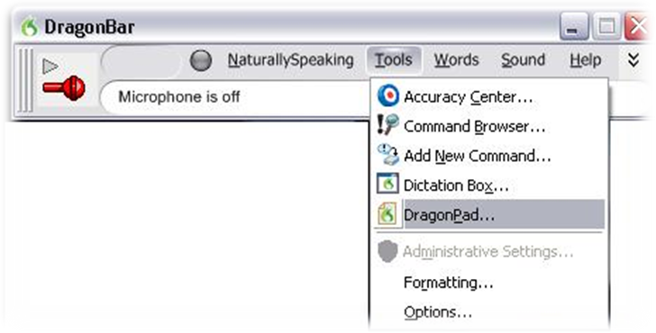
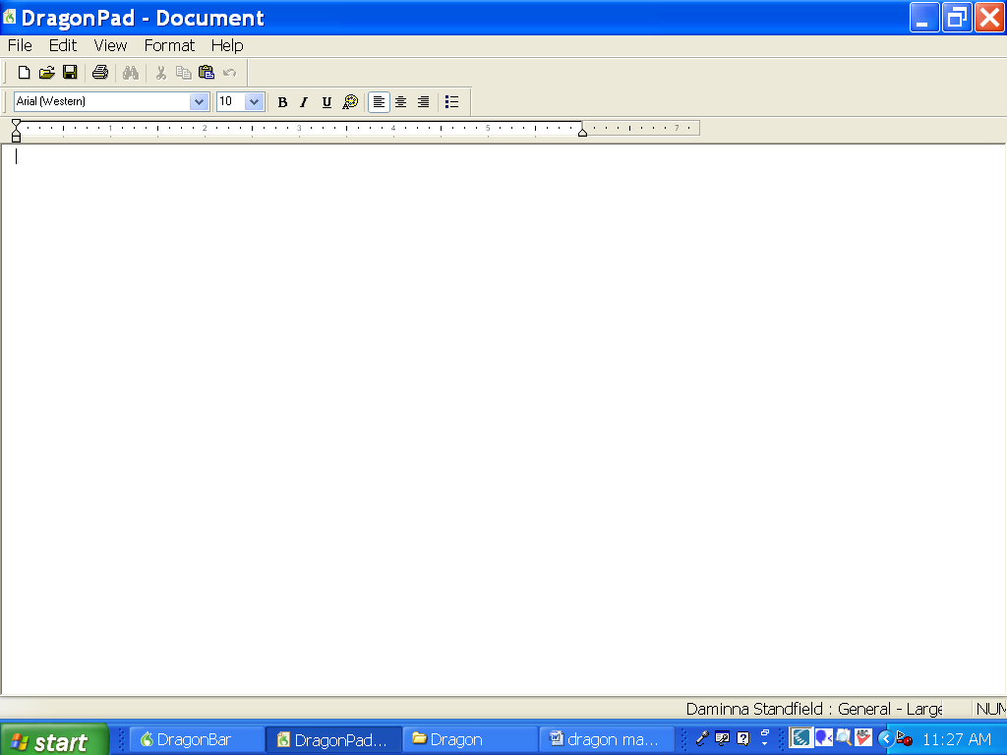
Then a word pad appears where you can speak into. You can then save the word document for later.

More on DragonPad: DragonPad is Dragon's built-in word processor, which is optimized for dictatation. DragonPad includes basic text formatting features as well as the ability to save and print documents.
You can use DragonPad when you do not need the capability of a full-featured word processor. When you have finished dictating, you can say "Copy All To Clipboard" to copy your text to the Clipboard and "Paste That" to copy the text from the Clipboard into any other program.
Although it is similar to WordPad, DragonPad is customized for use with Dragon and contains speech recognition features that are not available in WordPad.

Transcribing Audio
13: If you have a digital recorder and like to transcribe your voice then click on the Sound button on the Dragon Bar and then on the Transcribe Recording button.
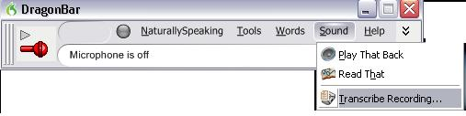

14: Then the below window appears which requires you to select the audio file that needs to be transcribed. Click on the browse button to locate and select your audio file. Dragon accepts Wav, mp3, Wma and DSS files.

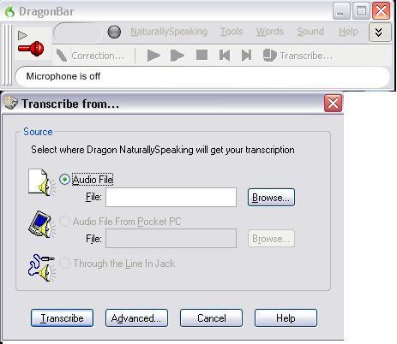
Once you have selected the file click on the Transcribe button to finish transcribing.

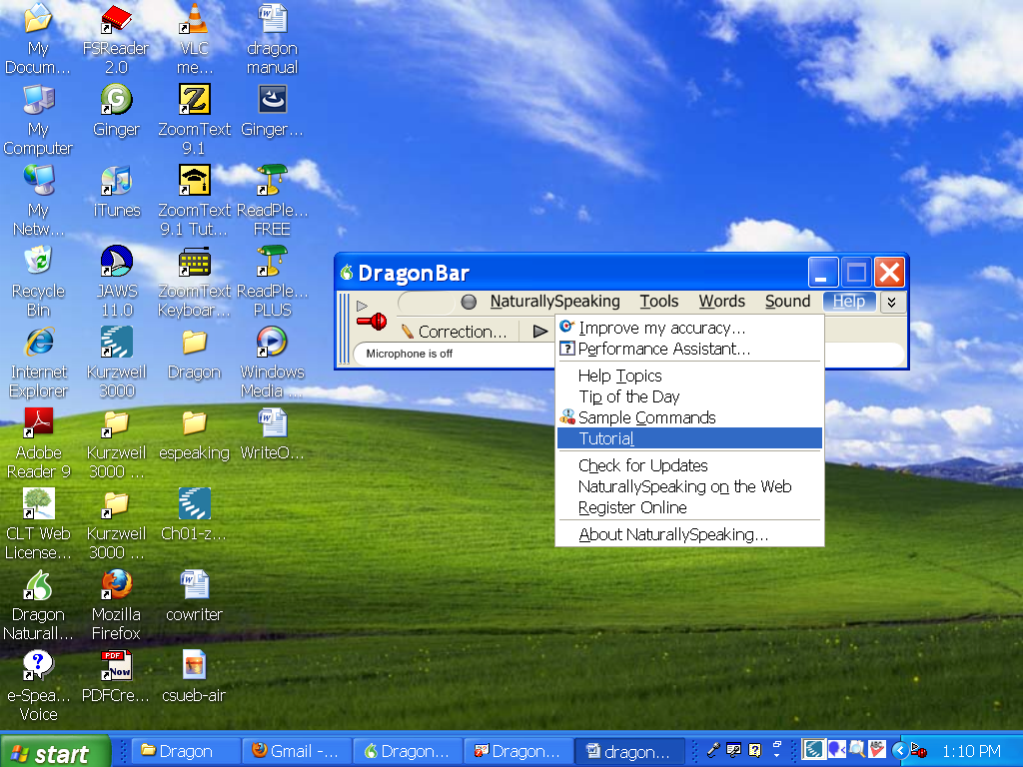

For additional help/training, go through the Dragon Naturally Speaking tutorials
- Click on the ‘Help’ tab on the Dragon bar as shown above
- Click on ‘Tutorial’ as shown above

- Once you click ‘Tutorial’, you should see the tutorial page as shown below
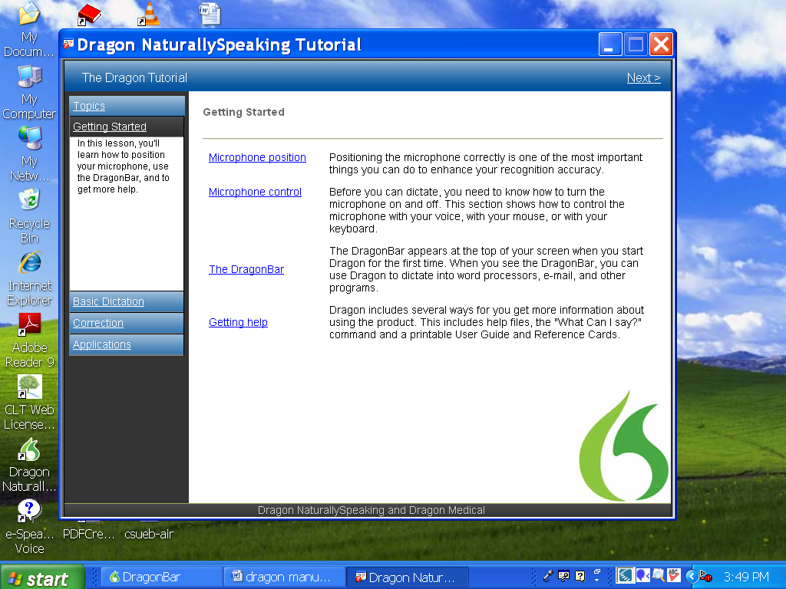
Note: Tutorial automatically shuts down microphone.
Explore the tutorial to learn more about DNS. When you close out of the DNS Tutorial turn on the mike again to begin using DNS voice command again.

QUICK SHEET COMMAND DRAGON NATURALLY SPEAKING COMMANDS

Controlling the Microphone:
- Go to sleep/Stop listening
- Wake up/Listen to me
- Microphone off
Getting Help:
- Give me help
- What can I say
- Display sample commands
Selecting and Correcting:
- Select <xyz>
- Select again
- Select the next <number> characters
- Select previous paragraph
- Select document
- Correct <word>
- Select all
- Unselect that
Inserting Lines and Spaces:
- New line
- New paragraph
- Press Enter
- Press Tab key
Capitalizing:
- Capitalize that; Cap that
- All caps on
- All caps off
- No caps
Editing and Formatting Text:
- Cut that
- Copy that
- Copy all to clipboard
- Paste it here
- Justify the document
- Right justify it
- Left align this line/paragraph
- Set Initial Indent to <number> Inches/Centimeters
- Set Hanging Indent to <number> Inches/Centimeters on This Page
- Save changes
- Dictate a file name (only needed if this is the first time the file has been saved)
- Click save
- Print Pages <number> to <number>", for example, "Print Pages One to Three

Undoing and Deleting:
- Scratch that
- Delete that
- Undo that
- Backspace <n>
Moving Around in Your Document:
- Move left <number> words
- Move down <number> lines
- Go to end of line
- Page up
- Page down
- Insert before <xyz>
Controlling your Desktop:
- Start <application name> (for example, Microsoft Word, Lotus Notes, Windows Explorer)
- Start <Folder name>
- Move down <number>
- Move up <number>
- Click Start
- Shut down computer
- Open <desktop icon name>
- Switch to <application name>
- Minimize window
- Maximize window
Email Commands
- Check for new mail
- View by sender
- Forward mail
- Reply to all
- Delete mail
- Create new message
- Subject field
- Go to body field
- Attach a file
- Check spelling
- Send mail
- View sent items folder
- Send and receive
Address Book and Contacts Commands
- Show the address book
- Display contacts folder
- Delete contact
Calendar Commands
- Switch to the calendar folder
- Show date
- View month
- Create a new appointment
- Invite attendees
- Cancel invitation
- Save and close

- *These commands are available only if the option Enable Natural Language Commands has been selected.

DRAGON VOICE SHORTCUTS
COMMAND TYPE EXAMPLE COMMAND

Search the Web. (default search engine)
"Search the Web for Italian restaurants in Boston."
Your default Web browser opens and displays the results of the default search engine on the given keywords.

Search specific Web sites.
"Search eBay for waffle iron.”
Your default Web browser opens and displays the results of searching eBay for the given keyword(s). Dragon NaturallySpeaking 10 supports this feature for the following Web sites:

• eBay | • Creative Commons
• Amazon.com | • Wikipedia
• About.com | • YouTube
• Answers.com

Find the top Web site from Google's "I'm feeling lucky".
"Find a site about weather."
Your default Web browser opens and displays Google's top-ranked page for the given keyword(s).

Search the Web with a specific search engine.
"Search Yahoo for movies in Boston."
Your default Web browser opens and displays Yahoo's search results for the given keywords. Dragon NaturallySpeaking 10 supports this feature for the following search engines:

- AltaVista
- AOL Search
- Ask.com

- Google
- Microsoft Live Search
- Yahoo!

Search the Web for a specific type of information.
"Search video for JFK inaugural address."
Your default Web browser opens and displays the results of a search on the given keywords in your default search engine's video category. Valid search categories are:
- Search (images | pictures | photos) for <XYZ>
- Search (video | movies) for <XYZ>
- Search (news | events) for <XYZ>
- Search (products | shops) for <XYZ
- Search (maps | places) for <XYZ>

QUICK VOICE FORMATTING
Delete the specified text or a range of text. Delete <text>
Delete from <text> to <text>
Delete <text> through <text>
Cut the specified text or a range of text. | Cut <text>  Cut from <text> to <text>  Cut <text> through <text>
Copy the specified text or a range of text. | Copy <text>  Copy from <text> to <text>  Copy <text> through <text>
Bold the specified text or a range of text. | Bold <text>  Bold from <text> to <text>  Bold <text> through <text>
Italicize the specified text or a range of text. | Italicize <text>  Italicize from <text> to <text>  Italicize <text> through <text>
Underline the specified text or a range of text. | Underline <text>  Underline from <text> to <text>  Underline <text> through <text>

For further Questions Contact US
Assistive Technology Services Office
Li1121
510-885-4366

rev.10/21/2010

