BB Ally General Usage and Tips

**Steps on converting course materials to accessible format for students.**

1. Click on the intended course.

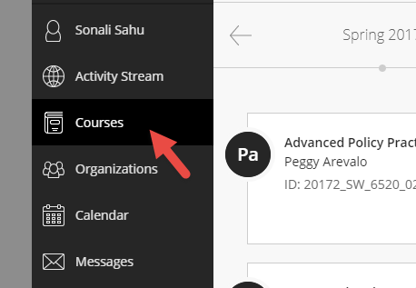 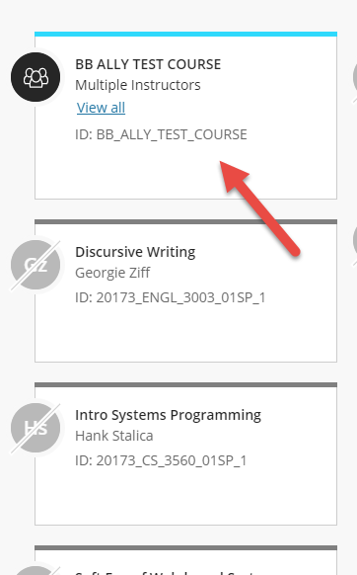

1. Click on the Course Materials Tab on the left

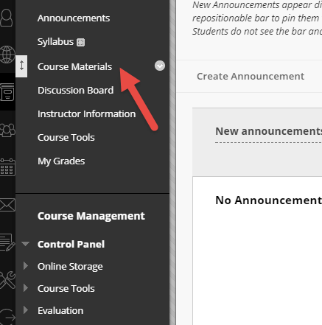

1. to Download the accessible version of the uploaded document.
   1. Click on the small drop down arrow on the right hand corner of the uploaded document in course materials.

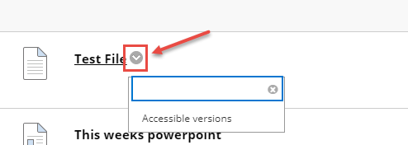

* 1. Click on the Accessible versions Option

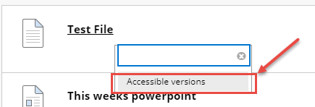

* 1. Select the desireed accessible version and Click on Download

